UTD Tech Report
A Mobile App for Managing Infectious Diseases on Campus
Jean-Felix Abellera
Carlos Hevia
Joshua Ruiz
Teena Thomas
Chinthoorie Yogalingam
Austin Mordahl
Abdul Hadi Khan
Faraz Khalid
Kevin Nguyen
Swathi Poseti
SE 6387 Capstone Project, Spring 2021
Naif Alatrash
James Chen
Evan Guo
Michael Smith
Meng-Hsiang Chang
Supervisor Dr. Rym Zalila-Wenkstern

1. Introduction
With the number of COVID-19 cases announced in and around the vicinity of UTD, students, staff, and faculty are constantly receiving daily health checks even though they do not come to campus. It has also
become difficult for students, staff, and faculty to determine the rate of new COVID-19 cases and visualize which places in the UTD campus are affected the most.
The goal of this project is to build a mobile app and system that a) provides live information of COVID-19 on campus, b) sends notifications to users, c) allows students, staff, faculty, and visitors to report COVID-19 cases, d) displays historical data and c) provides user access to COVID-19 news. This project can be used for any future infectious diseases and/or emergency health issues.
Three apps were designed and implemented by three teams, each comprising five graduate students. Before presenting the app UIs, we discuss the apps’ high-level features.

2. App Features

Heatmap
Users can view the campus and all its building units with a heat map representing the frequency of cases found in each building in real-time. This feature allows users to get a quick look at the current state of COVID infection on campus. Users can tap on buildings to get more detailed information (e.g., the specific number of cases).

Search
Users can search buildings by their names and codes to get their real-time status.

Notifications
Users are provided notifications regarding newly identified cases in places they have recently visited or places they regularly visit on campus.

Self-Reporting
This feature allows users to self-report COVID-19 infections and vaccinations through the UTD system.

News and Information
This feature provides current news regarding the virus outbreak. It provides useful links for testing centers, vaccination-related information, and information regarding cases in the broader community in which they reside. Since this information comes from a university-affiliated source, it is considered more accurate than other sources on the internet apart from associated government entities.
In addition, this feature allows the user to view historical data related to campus infections, sanitization efforts, etc.

3. App UIs

Team 1
Kevin Nguyen
Swathi Poseti

Austin Mordahl
Abdul Hadi Khan
Faraz Khalid

Heat Map Search
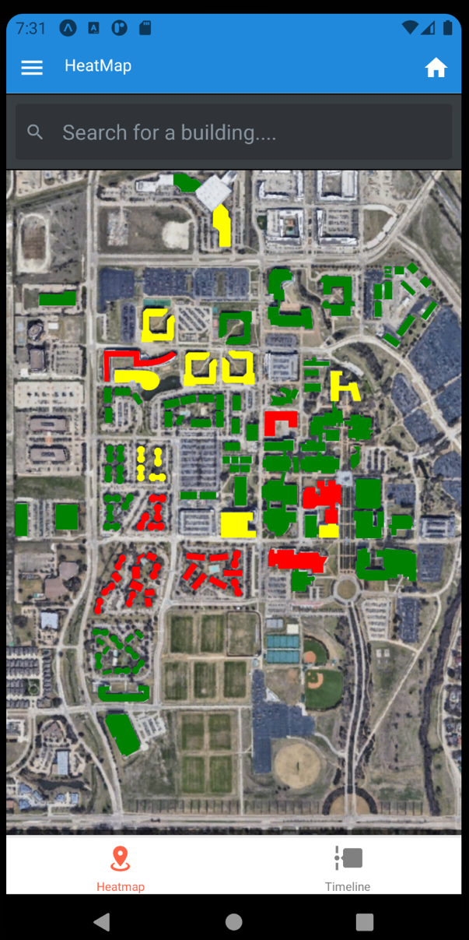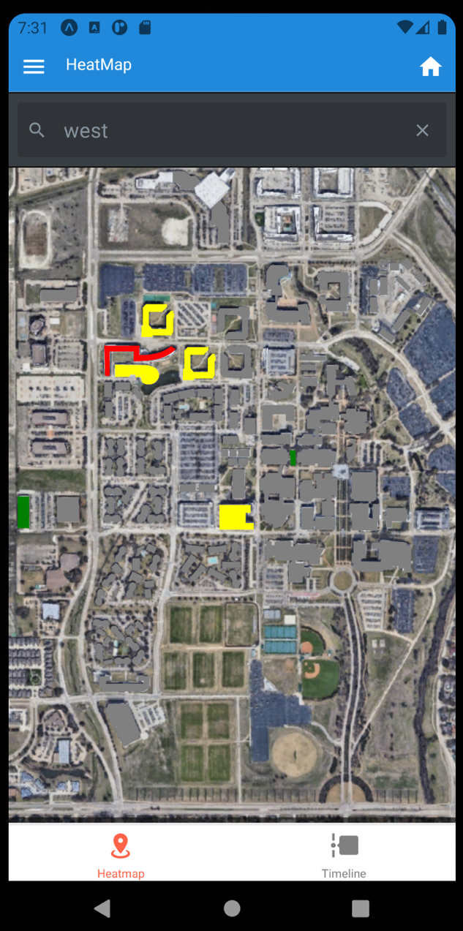

Notification Self-Reporting

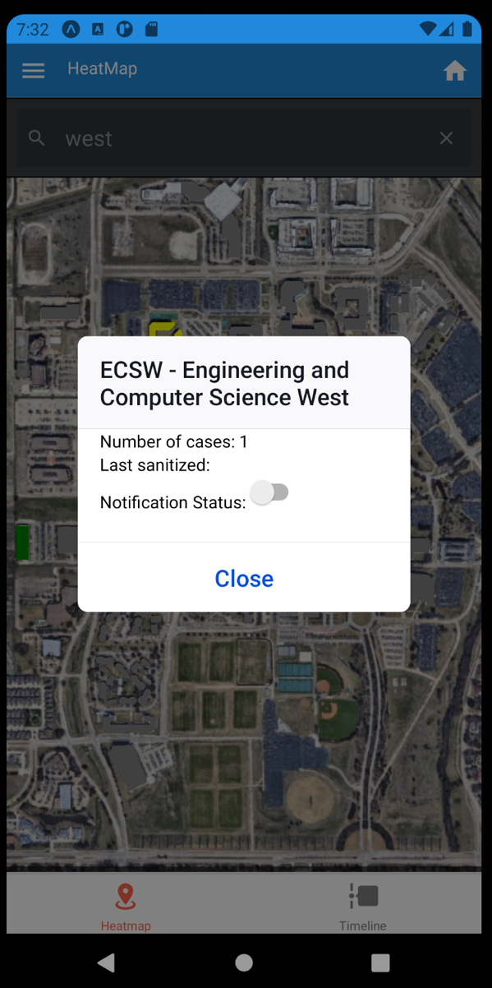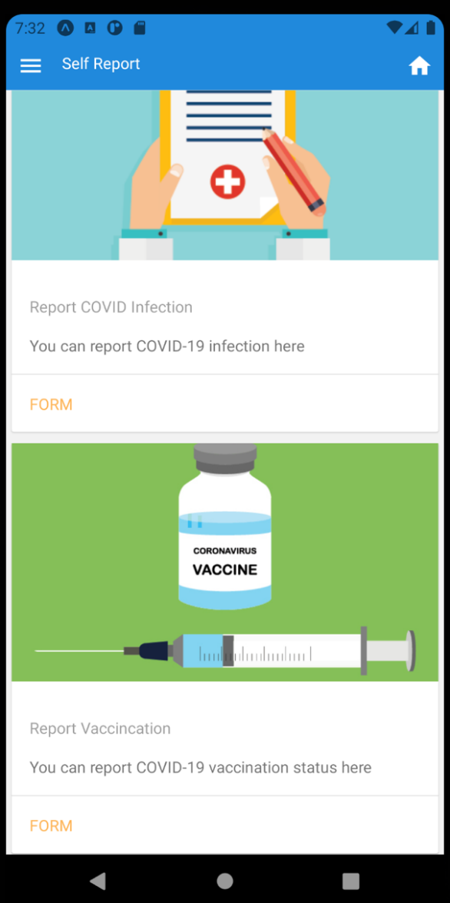

Team 2
Jean-Felix Abellera
Carlos Hevia
Joshua Ruiz

Teena Thomas
Chinthoorie Yogalingam

Heat Map

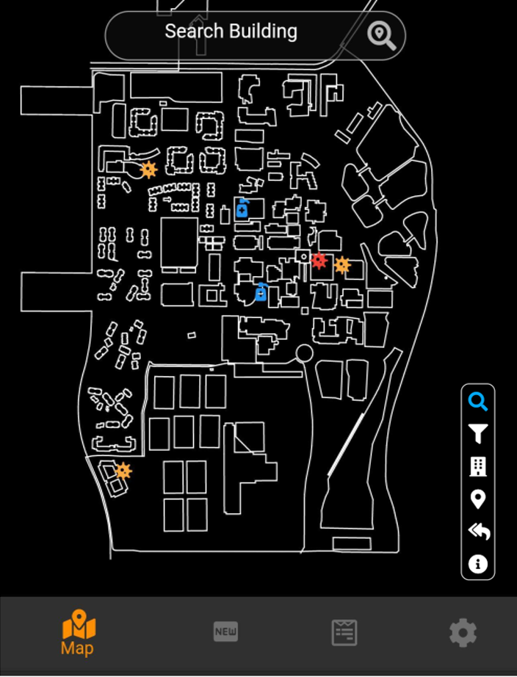

Icon | Functionality
 | A search bar appears where the user can type the building name or code.
 | A pop-up window is shown where the user can select the filter criteria based on date and/or infection rate.
 | Toggles between showing and hiding the building structures in the university map.
 | Toggles between showing and hiding the non-building structures in the university map.
 | Resets all the search and filters criteria to default.
 | Displays the icons details.

Building Infection History

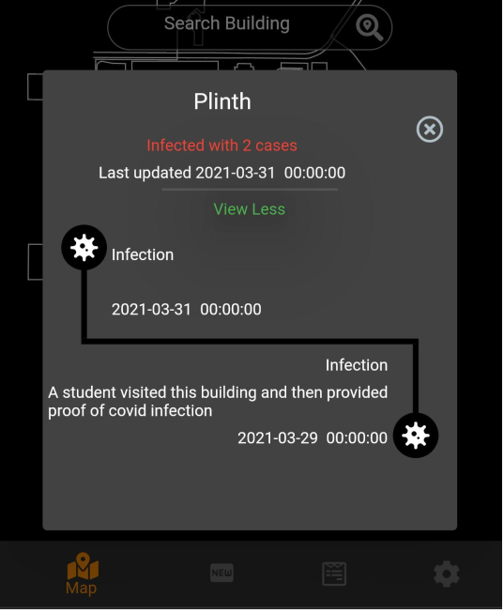

Team 3
Naif Alatrash
James Chen
Evan Guo

Jean-Felix Abellera
Carlos Hevia
Joshua Ruiz

Michael Smith
Meng-Hsiang Chang

Heatmap

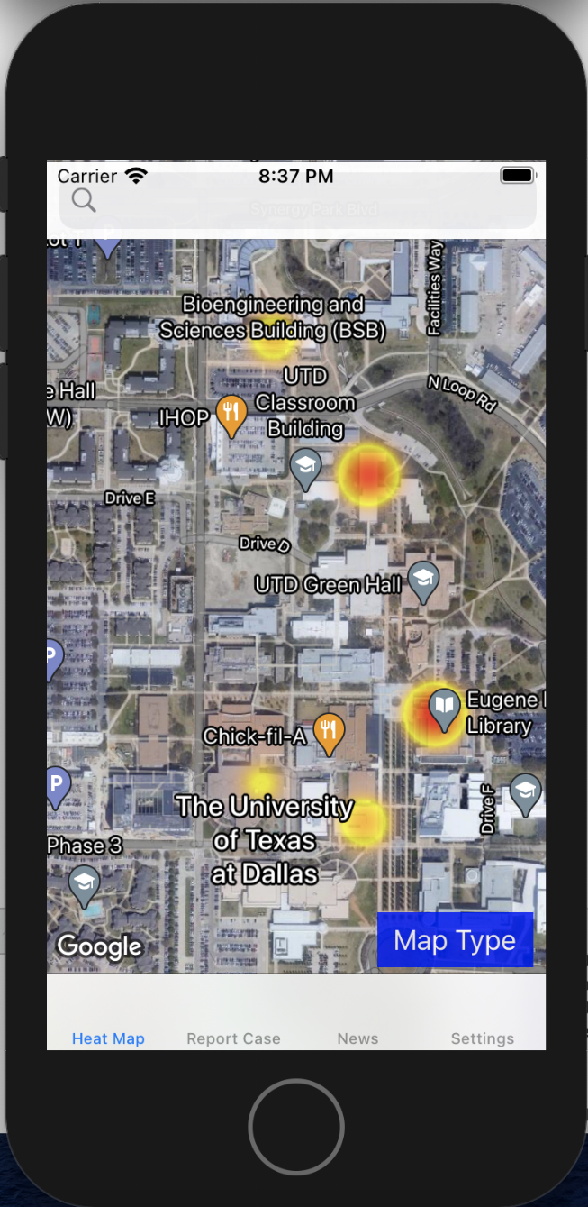
The heat map displays a building’s color relative to other buildings’ colors. If all infected buildings have relatively the same number of cases, all building’s colors will be relatively the same. Vice versa, if one building has a higher number of cases compared to other buildings, the building will have a deeper color while all other buildings will have lighter colors.

Search

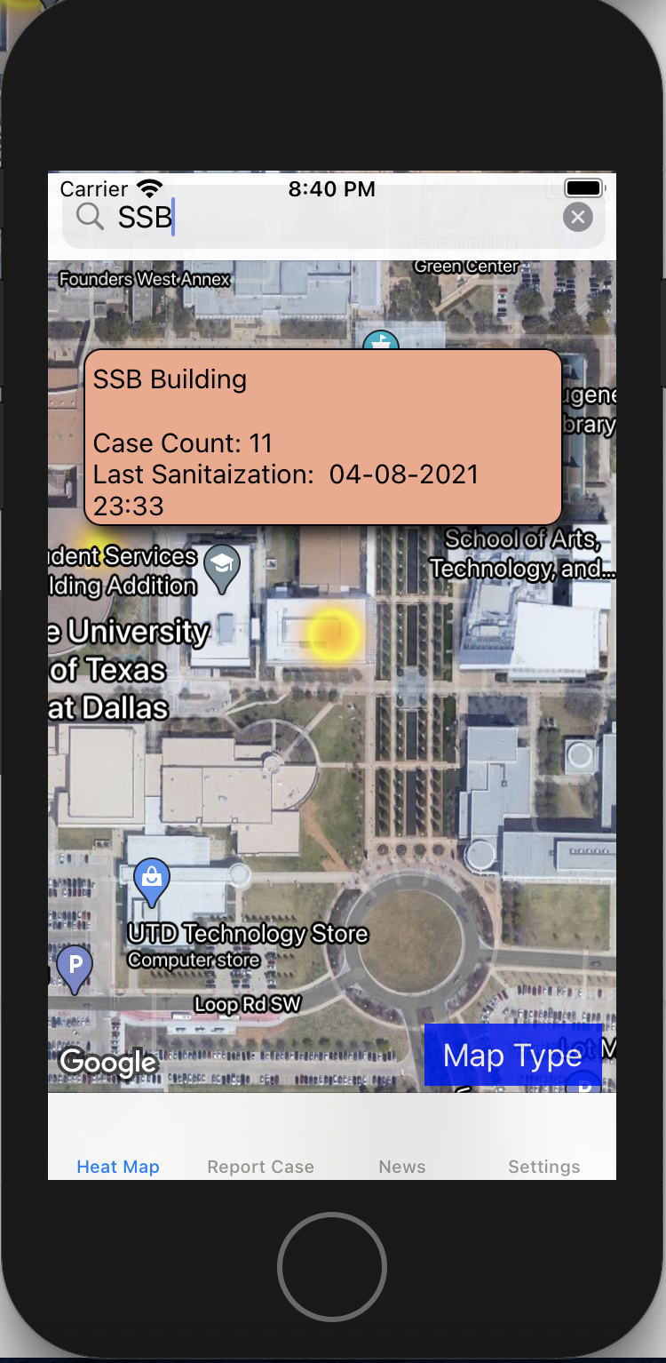
Users may type part of the building’s official name or the building’s acronym to be directed to that building.
If a user taps on a building, the system displays the building’s information related to COVID, such as the number of cases over a specific time period and time since the building was last sanitized.

Map Visualization
If a user does not like how the map is displayed, they can change the map display with button’s tap.
